**A**

**PROJECT REPORT**

**ON**

**“SMART SPARSH”**

G

**INTRODUCTION**

Submitted by

Team : **Access Denied**

Submitted to

Siliguri Institute of Technology in partial completion of Degree of B.Tech for the academic year 2023-24

Welcome to the documentation for Smart Sparsh, an innovative project developed by our team Access Denied .This device is designed to empower individuals with disabilities to effortlessly convey their needs , emotions , and messages through uncomplicated fingertip interactions and gestures through the use of a simple circuit

**HARDWARE COMPONENTS**

The Smart Gloves are equipped with the following hardware components:

**Arduino UNO :**

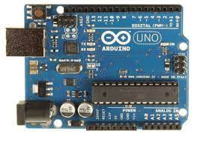

The Arduino Uno is a popular microcontroller board designed for hobbyists, students, and professionals to create a wide range of electronic projects and prototypes. It is part of the Arduino platform, which provides an open-source hardware and software ecosystem for easy development and experimentation with electronics and programming. Here is a brief description of the Arduino Uno:

1. Microcontroller: The Arduino Uno is powered by the ATmega328P microcontroller, which runs at 16 MHz and has 32KB of Flash memory for storing your program, 2KB of SRAM for data storage, and 1KB of EEPROM for non-volatile storage.
2. Digital I/O Pins: It has 14 digital input/output (I/O) pins, which can be used for various tasks, including reading sensors and controlling external devices. Six of these pins can be used for pulse-width modulation (PWM) output.
3. Analog Inputs: The Arduino Uno features 6 analog input pins, labelled A0 to A5, allowing you to read analog signals from sensors or other devices.
4. Power Supply: It can be powered through a USB connection to a computer or an external power supply connected to the DC barrel jack. The voltage range for external power is typically 7-12V. It has a built-in voltage regulator that provides a stable 5V supply for the board's operation.
5. USB Interface: The Arduino Uno uses a USB Type-B connector for programming and power supply. It can communicate with your computer via USB, making it easy to upload sketches (code) and monitor serial output.
6. Reset Button: A reset button is available on the board to restart your program or set the microcontroller into its default state.
7. Integrated LEDs: There are two built-in LEDs on the board. One (labelled "L") is connected to digital pin 13, and the other is the built-in "TX" (transmit) LED, which is used for serial communication.
8. Clock Source: The board uses a ceramic resonator as the clock source for the ATmega328P microcontroller.
9. Operating Voltage: The Arduino Uno operates at 5V, which is the voltage level used for its I/O pins.
10. Open-Source: The Arduino Uno is open-source hardware, which means its design files and schematics are freely available, and you can modify and build your own versions based on the design.

The Arduino Uno is well-suited for a wide range of projects, from simple blinking LED experiments to complex robotics and IoT applications. It can be programmed using the Arduino IDE, which supports a simplified version of the C/C++ programming language. The extensive library support and a vast community of users make it a great choice for both beginners and experienced makers.

**LCD Screen :**

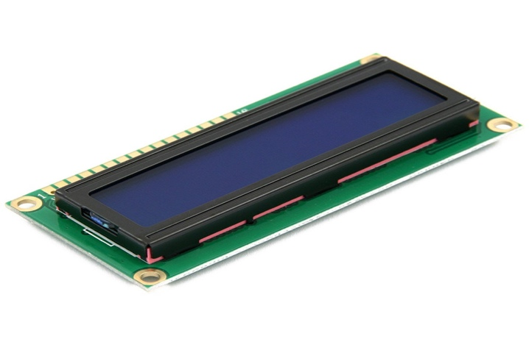

A Liquid Crystal Display (LCD) screen is a type of flat-panel display technology that is commonly used in a wide range of electronic devices, including televisions, computer monitors, smartphones, tablets, and more. LCDs are known for their slim profile, lightweight design, and energy-efficient operation. Here's a brief description of how LCD screens work and their key characteristics:

1. **Basic Operation**: LCDs work by manipulating the properties of liquid crystals, which are a type of organic compound that can change their alignment when an electric current is applied. The liquid crystals are sandwiched between two layers of glass or plastic, and their alignment is controlled by a grid of tiny transistors, forming the pixels on the screen.
2. **Pixel Structure**: Each LCD screen is divided into a grid of pixels. These pixels are the smallest units of the display, and they can emit or block light to create images. Each pixel is made up of three subpixels: one red, one green, and one blue. By varying the intensity of these three primary colors, the screen can produce a wide spectrum of colors.
3. **Backlighting**: LCD screens require a source of illumination to be visible. Most LCDs use a white LED backlight, located behind the liquid crystal layer. When the liquid crystals allow light to pass through, the individual subpixels control the color and intensity of that light.
4. **Display Types**:
   * **Twisted Nematic (TN)**: TN LCDs are known for their fast response times and are commonly used in computer monitors and some inexpensive TVs.
   * **In-Plane Switching (IPS)**: IPS LCDs offer better color accuracy and wider viewing angles compared to TN panels, making them suitable for high-quality displays.
   * **Organic LED (OLED)**: OLED displays use organic materials to emit light directly, eliminating the need for a separate backlight. This technology offers deeper blacks, better contrast, and thinner screens, often used in high-end smartphones and TVs.
5. **Resolution**: The resolution of an LCD screen refers to the number of pixels it contains horizontally and vertically. Higher resolution screens can display more detail and have crisper images.
6. **Viewing Angle**: LCD screens typically have limited viewing angles, especially TN panels. IPS panels offer wider viewing angles, making the content on the screen more visible from various positions.
7. **Response Time**: The response time of an LCD screen refers to how quickly the liquid crystals can change their state to display moving images. Faster response times are crucial for reducing motion blur in fast-paced content, such as video games.
8. **Power Efficiency**: LCD screens are known for their energy efficiency because they only consume power when the pixels need to change. This contrasts with older technologies like CRTs (Cathode Ray Tube), which continually consume power.
9. **Durability**: LCD screens are generally more durable than older display technologies. However, they can still be susceptible to physical damage, such as cracks in the glass or damage to the liquid crystal layer.
10. **Applications**: LCD screens are widely used in consumer electronics, such as televisions, computer monitors, laptops, tablets, and smartphones. They are also used in industrial displays, digital signage, medical equipment, and many other applications.

**Buzzer :**

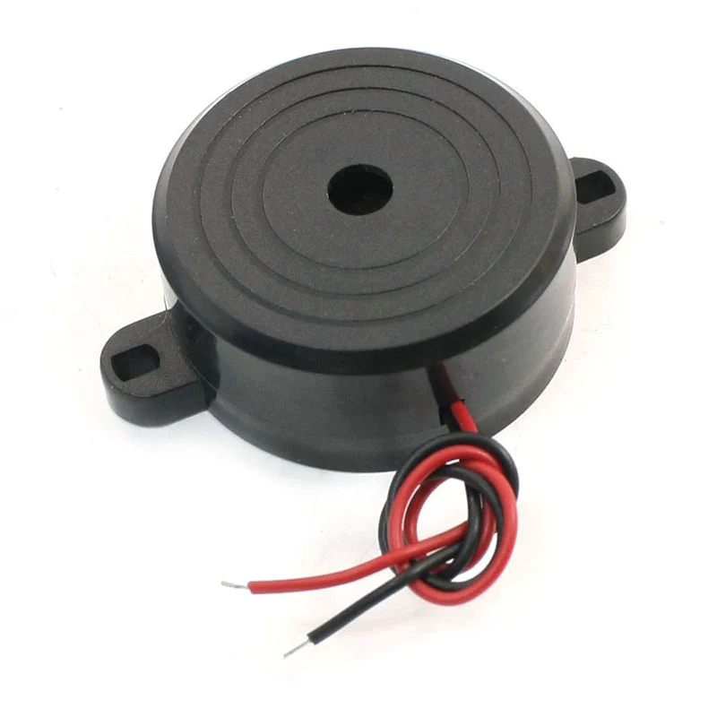

It's important to note that while LCD technology has been dominant for many years, it is now facing competition from newer display technologies like OLED and MicroLED, which offer certain advantages in terms of picture quality and flexibility

A buzzer is a simple electroacoustic device that produces a buzzing or beeping sound when an electrical current is applied to it. It is commonly used to provide audible alerts, notifications, or alarms in various electronic and electromechanical systems. Here is a brief description of the key components and operation of a buzzer:

1. Electromagnetic Coil: Buzzer typically consists of a coil of wire wound around a core, which may be made of iron or another ferrous material. This coil is the primary component responsible for creating sound in electromagnetic buzzers.
2. Diaphragm or Vibrating Element: Attached to the coil is a diaphragm or vibrating element, often made of thin metal or plastic. This diaphragm is responsible for creating the actual sound when it vibrates in response to the electromagnetic forces generated by the coil.
3. Housing: The coil and diaphragm are usually enclosed within a housing, which can be made of plastic or other materials. The housing helps direct and amplify the sound produced by the diaphragm.
4. Electrical Contacts: Buzzer terminals are provided to connect to an external electrical circuit. When an electrical current flows through these terminals, it energizes the coil, which, in turn, causes the diaphragm to vibrate.
5. Sound Production: When the coil is energized, it generates a magnetic field that attracts or repels the diaphragm. This causes the diaphragm to move back and forth rapidly, creating vibrations in the air. These vibrations produce sound waves, resulting in the characteristic buzzing or beeping sound associated with buzzers.

There are various types of buzzers available, including electromagnetic buzzers, piezoelectric buzzers, and mechanical buzzers, each with its unique operating principles and characteristics. Electromagnetic buzzers are common in applications like doorbells, alarms, and electronic devices, while piezoelectric buzzers are often used for their compact size and low power consumption in applications such as watches and small electronic gadgets.

**I2C Protocol :**

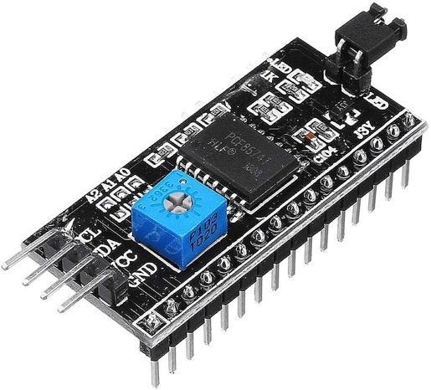

I2C, which stands for Inter-Integrated Circuit, is a popular serial communication protocol used in electronic devices and microcontrollers. It is often used to connect various components on a circuit board, enabling them to exchange data and control signals. Here's a brief description of the key components and aspects of the I2C protocol:

1. **Master and Slave Devices:** In an I2C communication setup, there are typically one or more master devices and one or more slave devices. The master device initiates communication and controls the data transfer, while the slave devices respond to the master's requests.
2. **SCL (Serial Clock) and SDA (Serial Data) Lines:** I2C communication relies on two bidirectional lines: SCL for the clock signal and SDA for the data signal. These lines are open-drain or open-collector, allowing multiple devices to share the same bus.
3. **Bus Arbitration:** I2C uses a multi-master architecture, meaning that more than one master device can be connected to the bus. Bus arbitration mechanisms determine which master gets control of the bus in case of a conflict.
4. **Start and Stop Conditions:** Communication on the I2C bus begins with a start condition (S) and ends with a stop condition (P). The start condition signals the beginning of a data transfer, and the stop condition indicates the end.
5. **7-bit and 10-bit Addressing:** I2C devices are identified by their unique addresses. Standard I2C devices use 7-bit addressing, allowing for up to 128 unique addresses. There is also an extended 10-bit addressing mode for devices that require more address space.
6. **Data Transfer:** Data is transferred in 8-bit bytes, with the most significant bit (MSB) sent first. The master device can read or write data to/from the slave devices, and acknowledgment bits are used to confirm successful data reception.
7. **Clock Speed:** The clock speed of the I2C bus is determined by the master device and is usually specified in terms of bits per second (bps). Common speeds include 100 kbps, 400 kbps, and 1 Mbps, with even higher speeds possible in some cases.
8. **Pull-Up Resistors:** Pull-up resistors are required on the SCL and SDA lines to ensure that the lines are pulled high when they are not actively being driven low by a device. The value of these resistors may vary depending on the bus capacitance and data rate.
9. **Acknowledge (ACK) and Not Acknowledge (NACK):** After receiving data bytes, the receiver sends an ACK bit to indicate that it is ready for the next byte. A NACK is sent if the receiver cannot accept more data or when the communication should end.
10. **Multi-Master Support:** I2C supports multiple master devices on the same bus. Bus arbitration methods, such as clock stretching, are used to prevent conflicts and ensure a single master controls the bus at any given time.
11. **Repeater and Extender Chips:** In larger systems or over longer distances, I2C signals may need to be extended or repeated. Specialized chips can be used to achieve this without signal degradation.

I2C is widely used for connecting various components in embedded systems, including sensors, displays, EEPROMs, real-time clocks, and more. It is known for its simplicity and versatility, making it a popular choice for inter-device communication in many electronic applications.

**POWER BANK :**

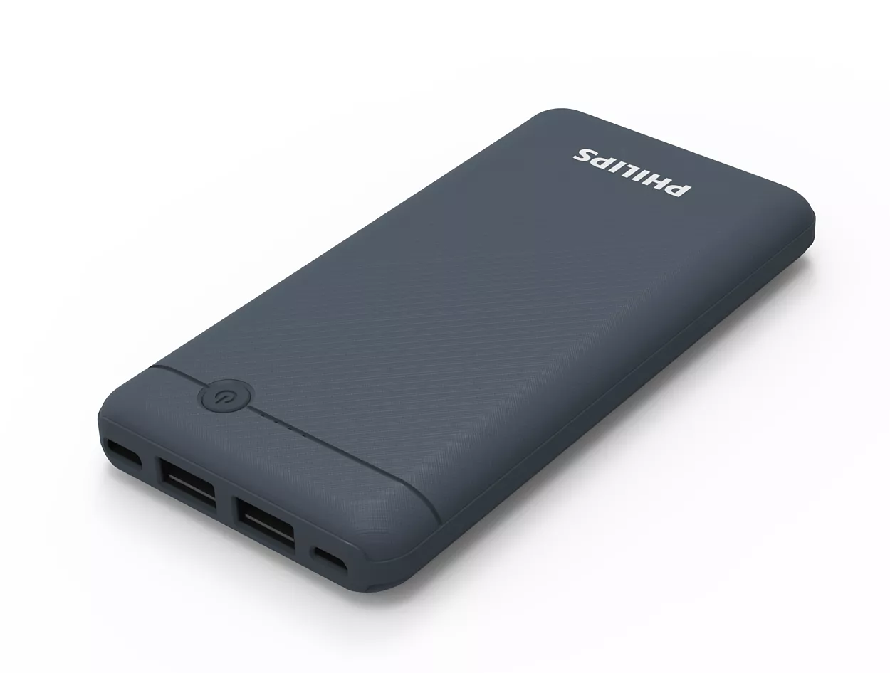

A power bank is a portable, compact device designed to store and supply electrical energy to charge or power electronic devices on the go. It serves as a convenient and reliable power source for a wide range of gadgets, such as smartphones, tablets, laptops, cameras, and more.

**SOFTWARE COMPONENTS**

**Arduino IDE :**

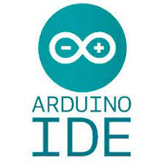

The Arduino IDE (Integrated Development Environment) is a software application that is used for programming and developing software for Arduino microcontroller boards. Arduino is an open-source hardware and software platform that is popular among hobbyists, students, and professionals for creating a wide range of electronic projects. Here's a brief description of the Arduino IDE:

1. **Cross-Platform:** The Arduino IDE is available for multiple operating systems, including Windows, macOS, and Linux, making it accessible to a broad user base.
2. **Open Source:** The Arduino IDE is open-source software, and its source code is available for modification and customization. This openness encourages community-driven development and the sharing of projects and libraries.
3. **Code Editor:** It provides a text editor for writing and editing Arduino sketches (code). The code is written in a simplified version of the C/C++ programming language.
4. **Library Support:** Arduino IDE comes with a library manager that allows users to easily install and manage libraries for various sensors, displays, and other components. This simplifies the process of integrating hardware into projects.
5. **Built-In Tools:** It includes tools for compiling and uploading code to Arduino boards. You can select the Arduino board type and the COM port, and then simply click a button to upload your code.
6. **Serial Monitor:** The IDE has a built-in serial monitor for debugging and communication with the Arduino board via the USB connection. This is useful for printing data and messages from your Arduino sketch to your computer.
7. **Examples and Tutorials:** The IDE comes with a range of example sketches and tutorials to help beginners get started with programming Arduino boards. These examples cover various aspects of the platform, such as reading sensors, controlling LEDs, and more.
8. **Community Support:** Arduino has a large and active community of users and developers who share their knowledge, projects, and libraries online. This community support can be valuable when you encounter issues or need inspiration for your projects.
9. **Third-Party Hardware Support:** In addition to official Arduino boards, the IDE supports a wide range of third-party boards that are compatible with the Arduino platform.
10. **Extensibility:** The Arduino IDE is extensible, allowing users to add custom libraries and tools to enhance their development experience.
11. **Open Source Development:** Arduino IDE development is ongoing, and contributions from the community are welcome. The source code is available on platforms like GitHub, and users can contribute to its improvement.

The Arduino IDE serves as the gateway for developing software for Arduino boards, making it accessible to people with varying levels of programming experience, from beginners to experienced developers and engineers. It simplifies the process of writing, compiling, and uploading code to Arduino boards, making it a valuable tool for creating a wide range of electronic projects.

**IDEA DETAILS**

Smart Sparsh is a user-friendly device that uses Arduino UNO as microcontrollers to help people with disabilities to communicate their needs and important messages using only their fingertips by making use of an LCD screen and a buzzer.

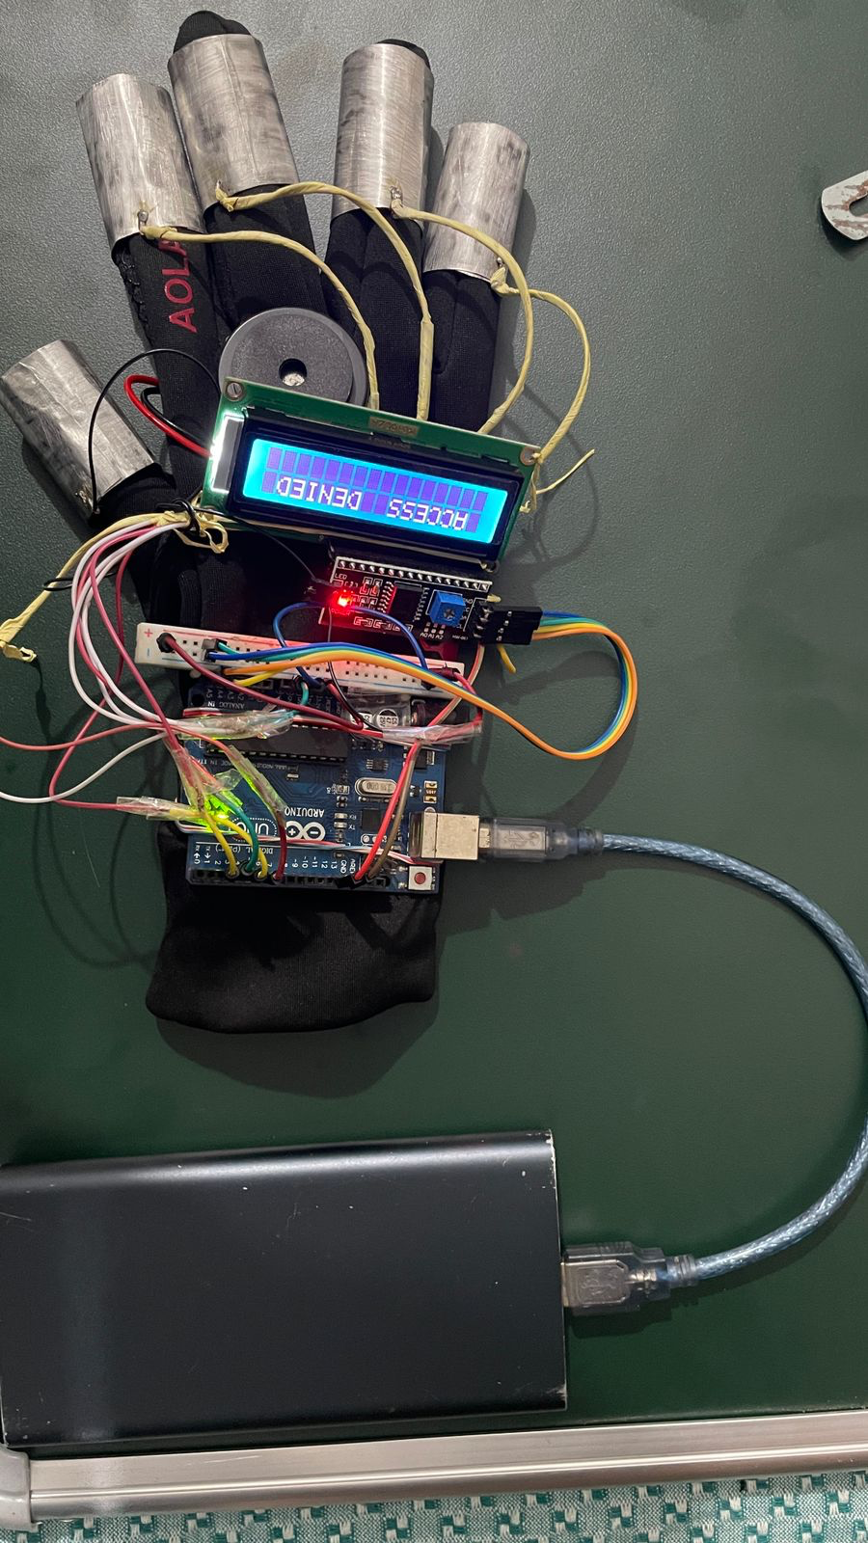

* **CONSTRUCTION :**

Smart Sparsh has been meticulously engineered with a primary focus on cost-effectiveness. This innovative device comprises several key components to provide a seamless user experience. At its core, it features an LCD display, serving as the primary output interface. The user interacts with the system through a basic circuit seamlessly integrated across four fingers. Meanwhile, the thumb is directly connected to a reliable 5V DC power supply. To enhance the user's interaction with the device, a buzzer has been thoughtfully incorporated into the design.

All these intricate connections and functionalities are meticulously orchestrated within the Arduino microcontroller, which serves as the brain of the Smart Sparsh system. This microcontroller is equipped with a finely tuned code that runs on its microprocessor, enabling it to interpret user input, process data, and produce meaningful output through the LCD display and the buzzer, creating a versatile and cost-effective solution for various applications.

* **WORKING :**

Our project smart sparsh works on a basic electrical circuit .The Arduino microprocessor reads the value as high when the circuit is complete and low when the circuit is open. There are 4 circuits connected to 4 fingers which is connected to ground and analogue pins on the Arduino UNO board and the thumb is connected to 5 volt pin on the Arduino UNO board such that when the thumb touches any of the 4 finger in any order of one finger at once 2 finger at once or 3 or 4 fingers at once depending on the finger a different code is run which display a different text on the lcd display accordingly

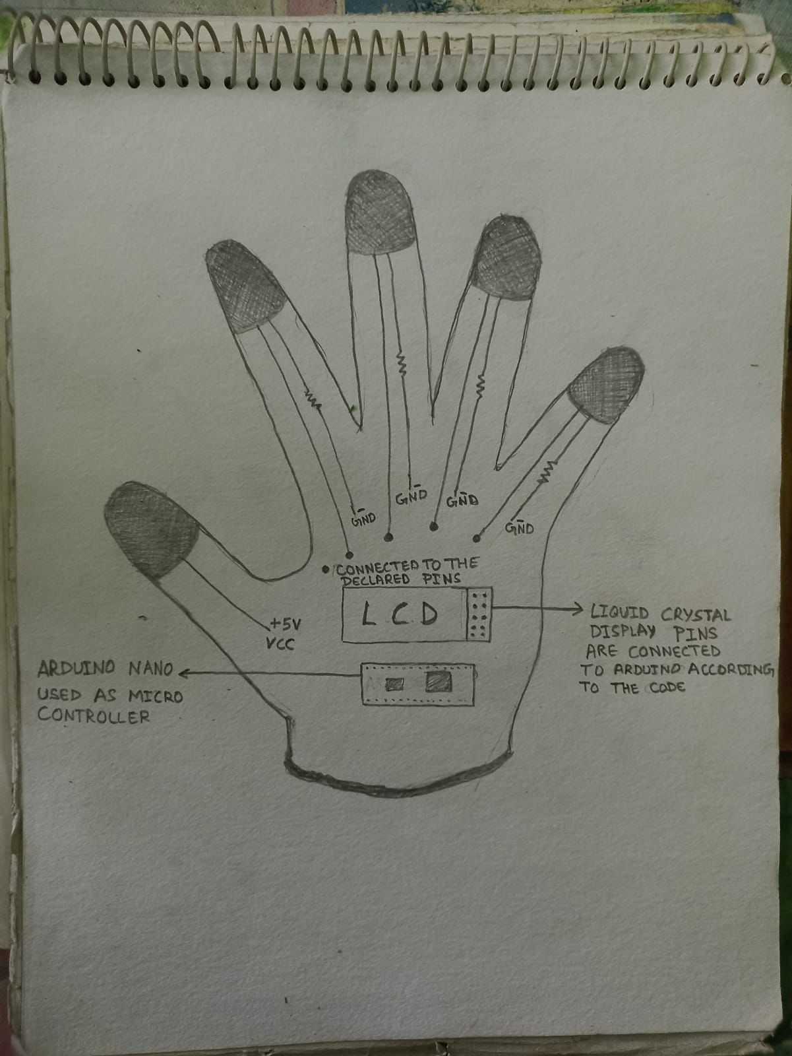

**Fig- Depiction of the circuit diagram of the working model**

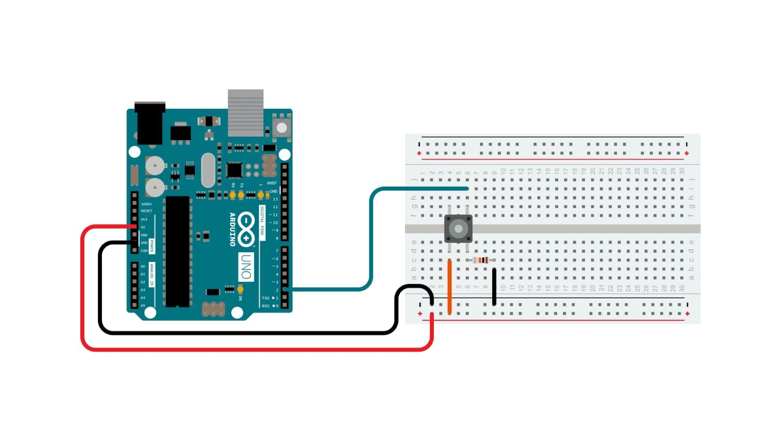

**Fig- Circuit diagram no.2**

**WORKFLOW CHART:**

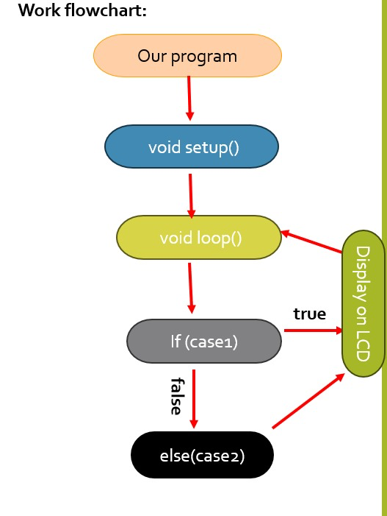

**USE CASES**

* Individuals with disabilities can use this tool to communicate their needs, desires and emotions with ease through the LCD Screen with the help of simple hand gestures.
* This technology can also be used to create remote controls for electric wheelchairs and other devices that can be operated via gestures.
* This device can also be used as switches to turn on or turn off the lights or other appliances in your home. You can assign each switch to a specific device or function.
* It can also be used to create a simple security system where the switches act as sensors. When a switch is triggered , it can activate an alarm system or send an SOS signal.
* On further improvement, it can be used to build custom controllers for gamers in order to provide a more realistic and improved immersive experiences for (VR) based experiences.
* This device could incorporate machine learning algorithms to analyze tactical data making it capable of recognising various touch interactions intelligently.

**Showstopper**

* LOW PRODUCTION COST : It uses a simple circuit instead of expensive sensors thereby making it easily accessible to the underprivileged classes of the society.



* LOW MAINTENANCE COST : Since the components used are inexpensive and easily available, it has a low maintenance cost.

**Dependencies**

* Only a limited number of command combinations are possible at a time.
* The messages displayed on the LCD Screen are not easily customisable by the common folks.
* In case of a malfunction, it is difficult to repair without expertise in the subsequent field.

**INTEGRATION**

Developers can connect the Smart Sparsh with an ESP32 or an ESP8266 to connect to the web. This will enable them to integrate the Smart Sparsh into their applications . This allows for customized gesture-to-action mappings and usage in various scenarios, from gaming to security fields , thereby expanding its application.

**FUTURE ENHANCEMENTS**

We are committed to continuously improving Smart Gloves. Some upcoming enhancements include:

* MP3 module with pre-recorded voice messages.
* Application that will enable customization of the messages displayed.
* Enhanced version that consists of various sensors .
* Improved model that will allow for Bluetooth and Wi-Fi connections
* Stable power source.

**CONCLUSION**

In conclusion, the Smart Sparsh case project has provided us with valuable insights into the potential of this innovative technology. Smart Sparsh has demonstrated its ability to enhance the quality of life for individuals with disabilities by offering a seamless and intuitive interface for communication, education, and accessibility. Through our analysis and research, we have identified several key takeaways:

1. **Inclusivity and Accessibility**: Smart Sparsh has the potential to bridge the digital divide and promote inclusivity by providing individuals with disabilities access to technology and information, enabling them to lead more independent lives.
2. **Adaptive Learning and Communication**: The project highlights the adaptability of Smart Sparsh, catering to a wide range of disabilities and communication needs, making it a versatile tool for users with diverse requirements.
3. **Technological Advancements**: The project underscores the impact of emerging technologies, such as AI and gesture recognition, in shaping the future of assistive devices and the potential to improve the overall user experience.
4. **Collaborative Efforts:** The success of Smart Sparsh can be attributed to the collaborative efforts of researchers, engineers, and individuals with disabilities, all working together to develop a solution that truly addresses the unique challenges faced by the target audience.
5. **Challenges and Opportunities**: While Smart Sparsh has made significant strides, there are still challenges to overcome, such as affordability and accessibility. However, these challenges also present opportunities for further research and development.

In summary, the Smart Sparsh case project underscores the transformative potential of technology to empower individuals with disabilities and promote inclusivity. By continuing to refine and expand the capabilities of Smart Sparsh, we can unlock even more opportunities for individuals to engage with the world, learn, communicate, and achieve their full potential. The project serves as a reminder of the incredible impact technology can have when harnessed for the greater good, and it inspires us to continue pushing the boundaries of innovation in the field of assistive technology.